One-day Lesson Plan Outline

Lesson Title: Microbes and the human body
Grade level =Middle School
Amount of time for this lesson = 30 minutes (1-3days)
Written by: Danielle Larson (B.A. in Marine Science)

- Standards and Safety and Materials:
A. Standards - (Both Wyoming and NGSS. Number and write it out) | NGSS:  - MS-LS1-6: construct a scientific explanation based on evidence for the role of photosynthesis in the cycling of matter and flow of energy into and out of organisms  - MS- LS1 -- Crosscutting concepts – Energy and Matter: within a natural system, the transfer of energy drives the motion and/or cycling of matter  - MS-LS2-3: develop a model to describe the cycling of matter and flow of energy among living and non-living parts of an ecosystem  - MS-LS2 – Crosscutting concepts – Energy and Matter: the transfer of energy can be tracked as energy flows through a natural system.
B. Safety Concerns: If none – “minimal safety concerns with regular class activity” | Some safety concern when it comes to scissors.
C. Materials (List of all materials needed for class including technology – like probes, tools, computer use, etc…) | Copies of the sheets attached at the end of the lesson plan, this will guide your classroom discussion.

- Objectives: (List them and make sure all are measurable! Bold the verbs. Three different levels!) Students will be able to…
A. SWBAT… | Research types of microbes and how they play a role in the human microbiome
B. SWBAT… | Compare different microbe sizes to visible objects

- Connections, Misconceptions, and Crosscutting Concepts:
A. Real world connections: (List them; e.g. Careers, Societal issues, etc…) | Bacteria can be used in the process of creating food that is consumed by humans including the bacteria that turns milk into cottage cheese.
B. Student connections: (List them; With what do they connect? Music, food, etc…) | Bacteria is used in certain milk products that are healthy for consumption. Atmospheric oxygen can be attributed to bacterial production as well as nutrient cycling. Photosynthetic organisms create useable energy that is consumed by higher trophic levels including humans. Students can also connect with the bad side of microbes, this includes E. coli. Nitrogen fixing microbes are capable of transforming atmospheric nitrogen to ammonia that is used in fertilizer.
C. Misconceptions: (List those AAAS misconceptions related to your content) | Microbes are all bad (Coil 2017); Microbes in the environment affect everyone the same way (Coil 2017);
D. Crosscutting Concepts: (List them and explain how they are used – e.g. patterns, cause/effect, scale/proportion/quantity, systems/system models, energy/matter, structure/function, and/or stability/change) | Scale can be addressed in this lesson because while some primary producers are visible to the naked eye, cyanobacteria is microscopic in origin. This can be addressed in a variety of ways including having students examine different types of microbes and the sizes associated with them. Another way is to demonstrate size comparisons using common household items.  Structure and function can be addressed by discussing the difference between prokaryotic and eukaryotic microbes. By identifying the major differences shown by these types of organisms the function of each can be explained in further detail.
E. Academic Language: [List the words/prefixes/suffixes that are addressed (focus on science vocabulary as well as instructions such as analyze, compare/contrast, etc…). What will the teacher do? How does the teacher address the words/prefixes/suffixes? How does the teacher get students to use those words, prefixes, and/or suffixes?] | Vocabulary addressed: microbe, microbiome, immune system, fingerprint, diverse, complex, diseases, metabolism, energy, fat, pathogenic,  Instructional vocabulary: research and compare  As the class continues it is important for the students to examine the size of microbes. For the activity, students will be researching different types of beneficial or pathogenic microbes.

- Catch/Engagement: (Hook them quickly – use all 5 senses at different times – should be no longer than 5 minutes.)
Hook: How to get student/class attention | https://www.youtube.com/watch?v=5DTrENdWvvM This NPR video discusses the human microbiome using animations that are similar to cartoons. There is an attached note taking guide to help retain vital information.

- Pre-test: (Same as post-test and short – to the point… Bold the objectives you are using – same as above!)
Pre-test and Post-test question(s)  Put the pre-test at the end of this day’s lesson plan (along with PowerPoint etc…)! | How do microbes compare to the size of the human body? Why are microbes important to the human body?

- Activity/Exploration: (Bold the verbs that match the objectives. Can have as many parts as needed – step by step directions.
(Remember: Include at least 1 science writing activity and probe activity for the unit!)
- Beginning of lesson | At the beginning of class have the students answer the pre-test questions above. By gathering the information from the pre-test question it can lead the discussion on microbe after the NPR video has been watched. This is an informative video about the importance in the difference between good and bad microbes.  For sixth grader classrooms use the note taking guide and have the students fill in the blanks. This will function as a formative assessment in the form of an exit ticket. After the video guide has been filled out, then provide the students with the size comparison worksheet.  The next part of this reason is to introduce a research project (this will take an additional day or two to complete). Assign groups or allow students to work in pairs to present different types of microbes. There are modifications for both the 7th and 8th grade classrooms listed at the bottom of this document. The point is to have your students look up a different type of microbes associated with humans and/or food. I have provided a list of potential microbes. It is up to you to include viruses, it is a group that can be debated in its position in microbes.
- Middle of lesson | In all classrooms it is important to talk about the size differences in microbes. It is part of the definition of microorganisms, that they aren’t visible to the human eye.  After a discussion about the sizes of microbes allow 10 minutes for students to decide on the microbe they want to research together. There is an additional page of questions the students should answer and turn in to you prior to completing the assignment. Depending on the grade level being taught you can make extensions to the research project. Allow your students to have ample time to research their microbes
- End of lesson | In the last 5-7 minutes of the class, bring your students back together to discuss the pre-test questions and some of the information they have found during the research portion of the class.
- Are lecture (<11 min), lab, etc… clearly explained? Are directions and student expectations explicit?  Did you do this? Yes or No | Some lecture is needed when the class draws to a close to discuss the concepts of microbes. However, most of the first days class period should be dedicated to collecting information on their choice of microbe. Depending on the grade level of the class being taught extensions on the
- PowerPoints, lab sheets, notes, answer keys, etc… included?  Did you do this? Yes or No | I have not included any PowerPoints but there are some sheets attached to assist with the direction of the class.

- Review/Essential Questions/Explanation: (Should be closely related to pre/post tests!)
A. Low Level Questions – (Knowledge/Remembering and/or Comprehension/Understanding) | What are some microbe categories? How do microbes help the human body?
B. Middle Level Questions – (Application/Applying and/or Analysis/Analyzing) | If the human microbiome is important for our health, how does this compare to the microbial community within the soil surround plants?
C. High Level Questions – (Synthesis/Evaluating and/or Evaluation/Creating) | Propose some advancements that could come from research into microbial communities? What are the pros and cons of determining if the human microbiome has changed throughout history?

- Assessments (Post-test)/Evaluation: (Bold the verbs that match the objectives and are in the activity.)
A. Formative: (Check for learning in class?) | As an exit ticket for the pre and post-test questions. Another version of a formative assessment is checking that the note taking sheet for answers.
B. Post-test: ( “Same as pre-test”; Compare w/pre-test to inform teaching!) | How do microbes compare to the size of the human body? Why are microbes important to the human body?
C. Summative: (Check for final learning/understanding) – e.g. Students turn in constructed project and take 20 question multiple choice test. | This is a portion of the information that you can teach in talking about ecosystems. Since some microbes are photosynthetic, like cyanobacteria, which can lead to discussions about food webs and primary producers.
D. Explain how the data informs tomorrow’s teaching. For example, “The class post-test average must be a 80% or the next class begins with a 10 minute review/discussion of today’s material followed by another post-test of the same material.” | The data collected from the formative assessments can help you determine if you need to review the information the following day. Also, by having your students present information they gathered on their microbes it will give you an idea where they stand in terms of presentation skills.

- Timeline for your lesson:
A. Catch  B. Pre-test  C. Activity – 4 parts  D. Review and Post-test  Add/change as needed | The catch for this lesson is five and a half minutes. When used in the 6th grade classroom the video will need to be played twice taking up approximately 11 minutes due to the note taking guide.  Answering the pre-test question by providing 3-4 minutes for students to sufficiently answer.  The activity will depend on the grade level being taught.  The review consists of gathering the data from the pre-test. At the end of the class you should check in with the students to see

- Enrichment/Elaboration: (Include one enrichment activity for students that might finish early)
What enrichment activities are offered for students in this lesson (beyond what is taught)? | C-more is an education and outreach program that examines oceanographic microbes. http://cmore.soest.hawaii.edu/education.htm  This website contains quizzes and interactive information about microbes.

- IEP Accommodations/Differentiation/Diversity: What accommodations will you use to support struggling learners?
What accommodations are used to support struggling learners?

- Grade Level modifications:
6th grade | There is a fill in the blank guide, if this is used it would be best to play the video twice. The first time have the students watch the video and the second for them to fill in the information they might have missed.  https://www.youtube.com/watch?v=5DTrENdWvvM  Since this video is the hook to the lesson it is best to hand out the note taking guide prior to watching the video.  The second activity in this lesson is to have students cut out size comparisons of microbes. Taken from e-Bug (http://www.e-bug.eu/junior_pack.aspx?cc=eng&ss=2&t=Introduction%20to%20Microbes)
7th grade | Have your students examine the properties of the microbe, including the size and what causes the microbe to be beneficial or pathogenic.
8th grade | Have the students create posters on the information and present it to the class.

- References:
  - Coil, D. (2017, February 09). Microbial Myths: common misconceptions about microbes (with some extra focus on those in the built environment). Retrieved from https://www.microbe.net/simple-guides/microbial-myths-common-misconceptions-about-microbes-in-the-built-environment/

Video Note Taking Guide
- There are _____ ________ more cells from microorganisms in or on the human body than human cells.
- Without ________ ___________ the human body doesn’t seem to do as well, humans don’t seem to be as __________ and might get sick _______ often.
- Our microbiome begins with our _____________.
- An individual’s microbiome can be compared to a _______________.
- Our microbiome might be assisting our ____________ _____________ in being able to determine what microbes to _________ off and things that aren’t a ___________.
- As adults _________ act as the first line of defense against _________ that try to infect our bodies.
- Microbes in the human body vary depending on where they live:
  - Wet places –
  - Oily places –
  - Dry places –
- The ___________ and most ______________ microbial habitat is the gut. It seems to be the most __________ and ___________.
- Microbes seem to help regulate our _______________, how much _________ we burn and how much _______ we store.
- Scientists think one reason a lot of ____________ are increasing is because we have __________ key gut microbes.

If humans are as big as Europe

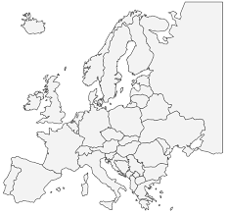

A fungus would be the size of a football field

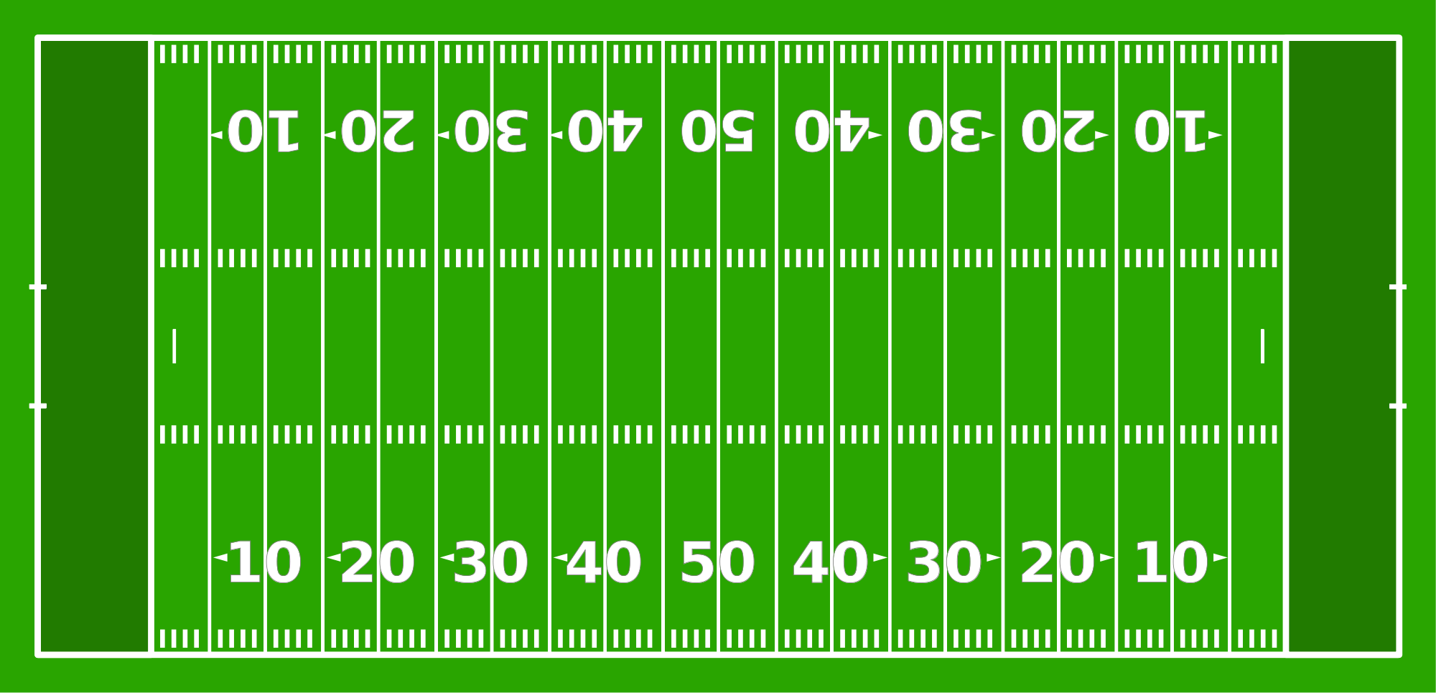
A bacterium would be the size of a bus

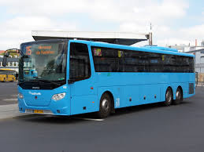

List of microbes:
- Pathogenic bacterium – Bordatella pertussis, Yersinia pestis, mycobacterium tuberculosis
- Pathogenic Protozoan – Plasmodium falciparum
- Pathogenic Fungus – Trichophyton rubrum, Trichophyton mentagrophytes
- Probiotics – Lactobacillus acidophilus, Lactobacillus bulgarius, Lactobacillus reuteri, Streptococcus thermophilus, Saccharomyces boulardii, Bifidobacterium bifidum, Bacillus subtilis

Research questions:
- Microbe researching:
- Beneficial or pathogenic:
- What does this mean for the human body?

